Московский государственный технический
университет им. Н.Э. Баумана.

Факультет «Информатика и управление»

Кафедра ИУ5. Курс «РИП»

Отчет по домашней работе

вариант 4

Выполнил: |  | Проверил:
студент группы ИУ5-51Б |  | преподаватель каф. ИУ5
Белоусов Евгений |  | Гапанюк Ю.Е.
Подпись и дата: |  | Подпись и дата:

Москва, 2019 г.

1. Задача
В рамках домашнего задания студент разрабатывает веб-приложение на основе технологий Python, Django, JavaScript, MySQL.
Вариант | Субъект | Отношение | Объект
4 | Пользователь | Комментарий | Новость

2. Скрины работающей программы
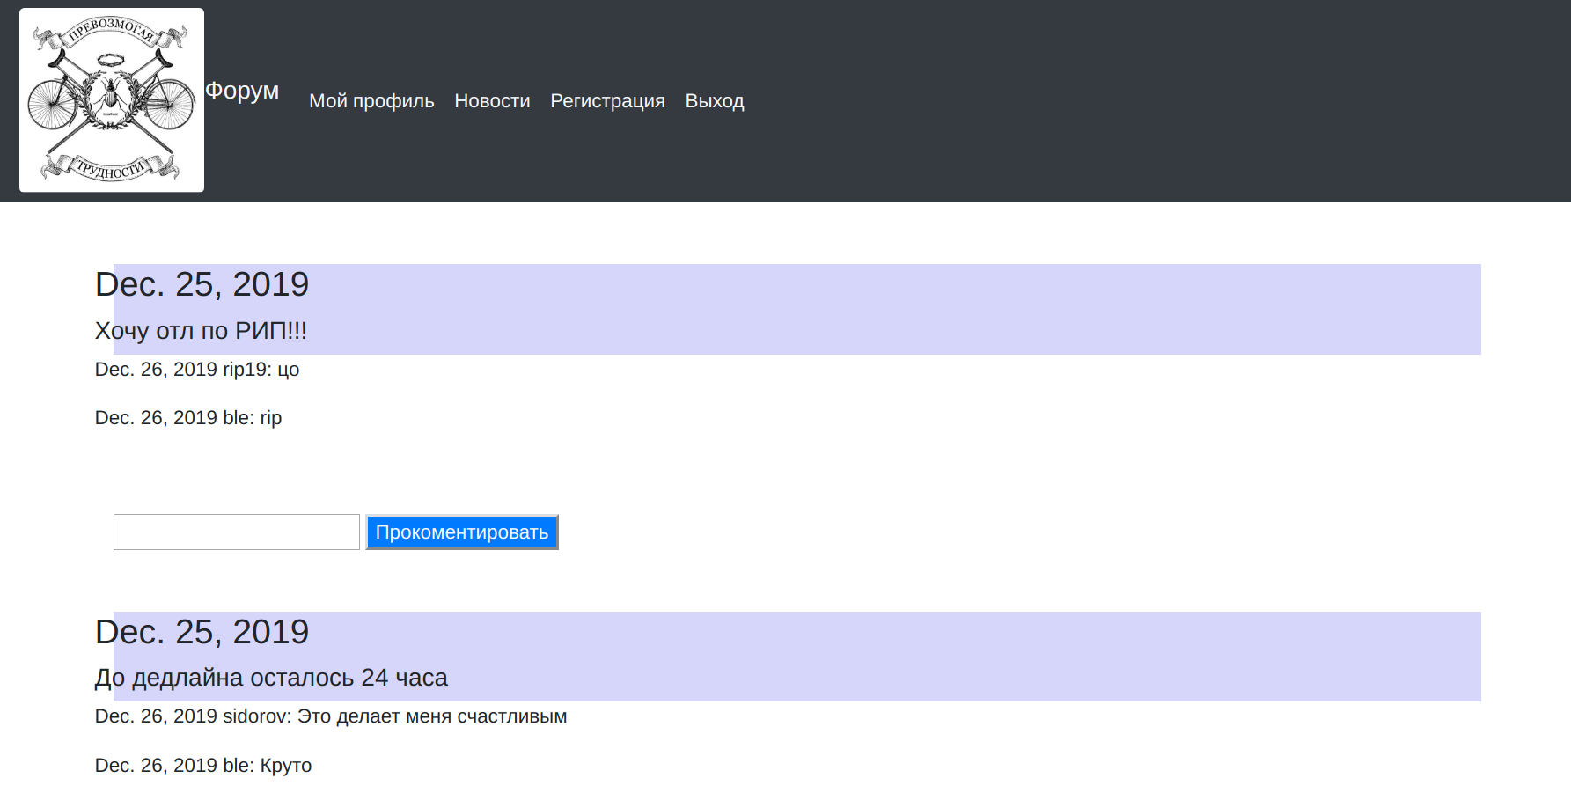

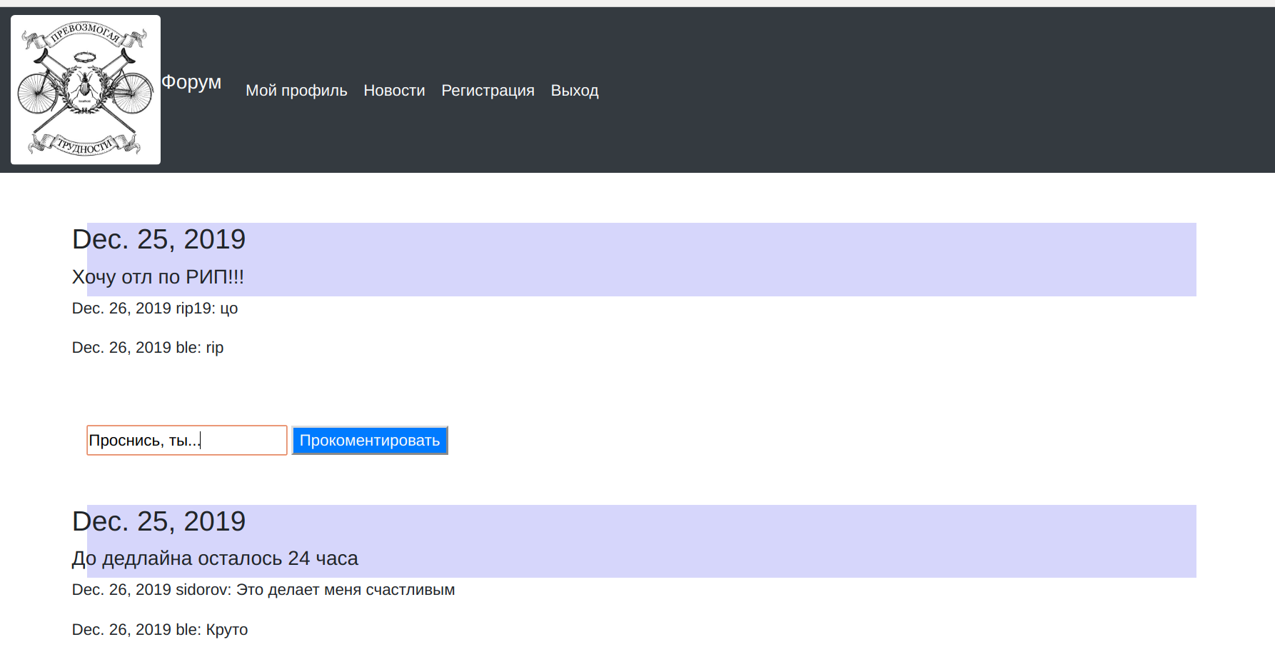

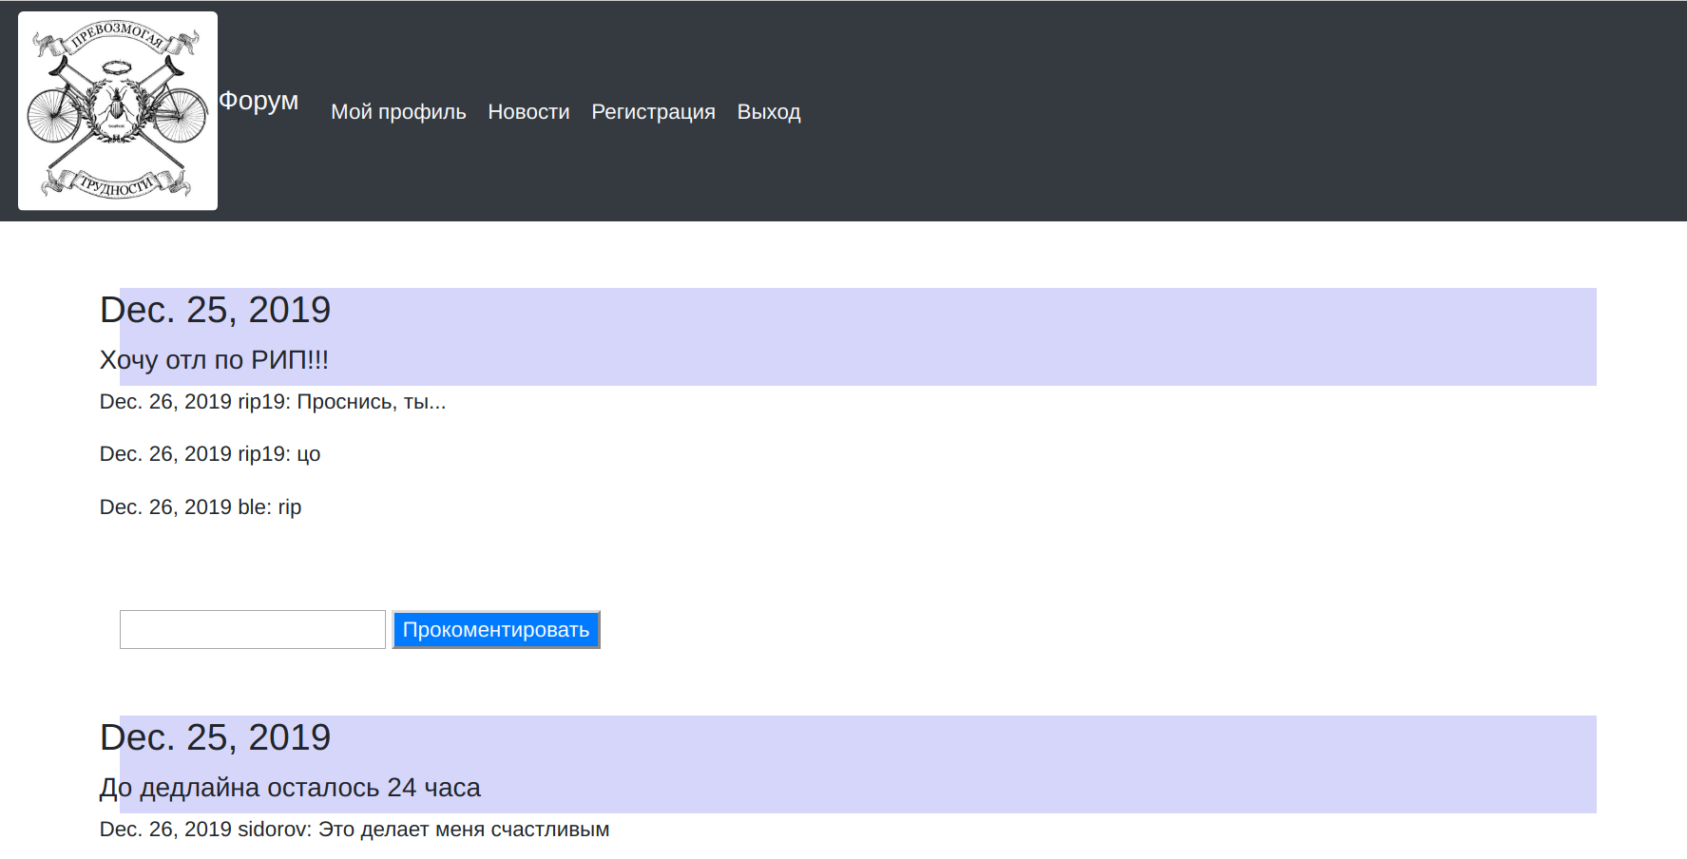

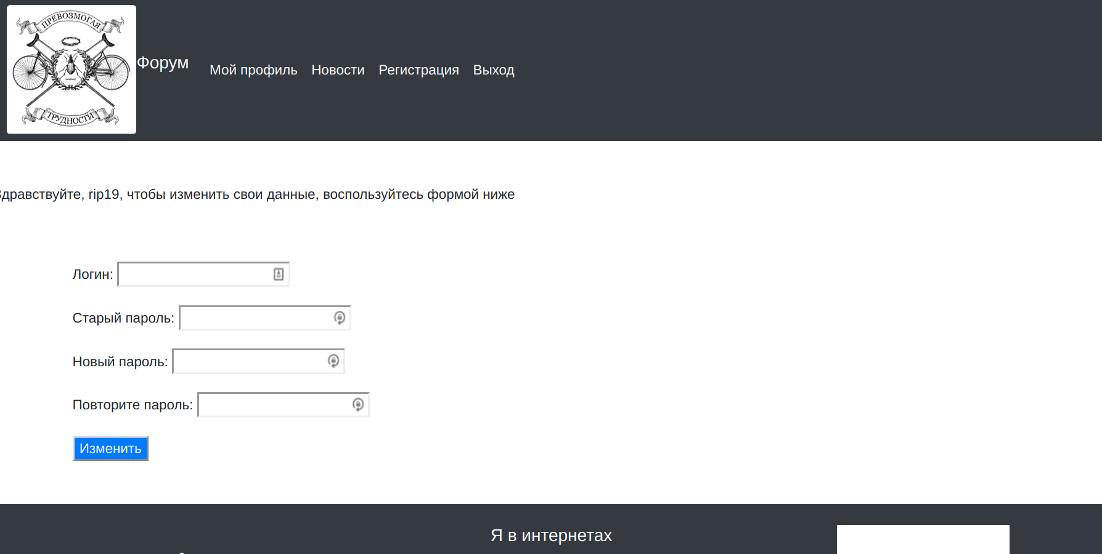

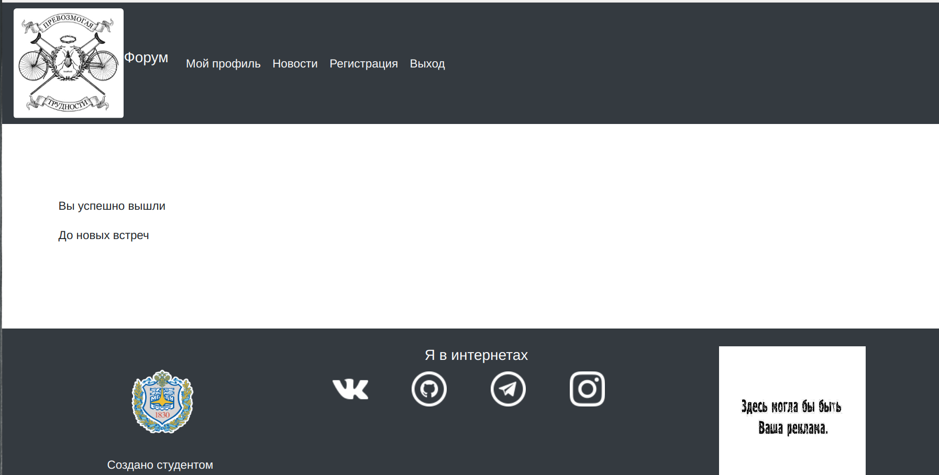

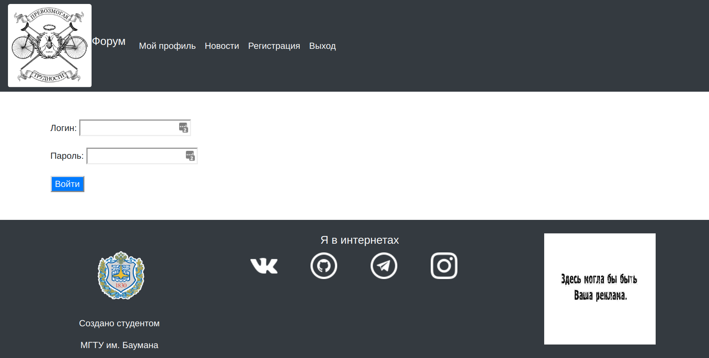

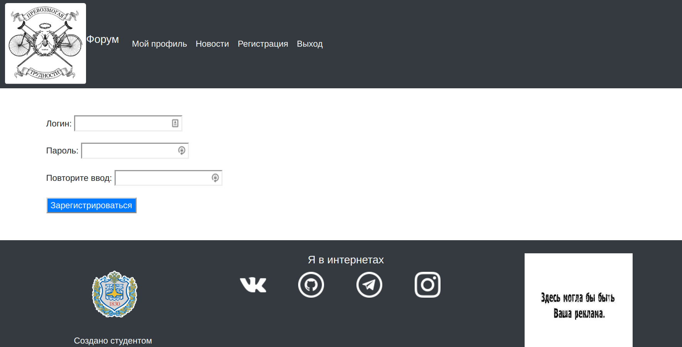

3. Исходный код программы
.red{
color: #fd0202;
}
.prevozmogaya-trudnosti{
width: 150px;
height: 150px;
}
.bauman{
width: 150px;
height: 150px;
}
.reklama{
width: 200px;
height: 200px;
}
.empty{
width: 200px;
height: 166px;
padding: 83px;
}
.my-head{
position: fixed;
width: 100%;
z-index: 2;
}
.free-space{
height: 50px;
}
.new{
background-color: #d6d6fb;
}

{% extends "basic_template.html" %}
{% block title %} Авторизация {% endblock %}
{% block body %}
<div class="free-space"></div>
{% if was_wrong %}
<div class="container">
<div class="row">
<div class="col-sm mx-auto">
<p>Неправльный логин или пароль</p>
</div>
</div>
</div>
<div class="free-space"></div>
{% endif %}
<div class="container">
<div class="row">
<form method="POST" class="col-sm">
{% csrf_token %}
{{ form.as_p }}
<button class='bg-primary text-light'type="submit">Войти</button>
</form>
</div>
</div>
<div class="free-space"></div>
{% endblock %}

{% extends "basic_template.html" %}
{% block title %} Выход {% endblock %}
{% block body %}
<div class="free-space"></div>
<div class="free-space"></div>
<div class="container">
<div class="row">
<p> Вы успешно вышли</p>
</div>
<div class="row">
<p> До новых встреч</p>
</div>
</div>
<div class="free-space"></div>
<div class="free-space"></div>
{% endblock %}

{% extends "basic_template.html" %}
{% block title %} Новости {% endblock %}
{% block body %}
<div class="free-space"></div>
<div class="container">
{% for new in news %}
<div class="new">
<div class="row">
<h3>{{ new.date }}</h3>
</div>
<div class="row"><h5>{{ new.text }}</h5></div>
</div>
{% for comment in new.comments %}
<div class="row">
<p>{{ comment.date }} {{ comment.user }}: {{ comment.text }}</p>
</div>
{% empty %}
{% endfor %}
<div class="free-space"></div>
<div class="row">
<form method="POST" class="col-sm">
{% csrf_token %}
<input type="text" name="add-comment{{ new.id }}">
<button class='bg-primary text-light'type="submit">Прокоментировать</button>
</form>
</div>
<div class="free-space"></div>
{% empty %}
<p>Пока нет новостей</p>
{% endfor %}
</div>
<div class="free-space"></div>
{% endblock %}

{% extends "basic_template.html" %}
{% block title %} Персональная страница {% endblock %}
{% block body %}
<div class="free-space"></div>
{% if name %}
<p>Здравствуйте, {{ name }}, чтобы изменить свои данные, воспользуйтесь формой ниже</p>
<div class="free-space"></div>
{% endif %}
{% if changed %}
<p>Данные успешно изменены</p>
<div class="free-space"></div>
{% endif %}
<div class="container">
<div class="row">
<form method="POST" class="col-sm">
{% csrf_token %}
{{ form.as_p }}
<button class='bg-primary text-light'type="submit">Изменить</button>
</form>
</div>
</div>
<div class="free-space"></div>
{% endblock %}

{% extends "basic_template.html" %}
{% block title %} Регистрация {% endblock %}
{% block body %}
<div class="free-space"></div>
<div class="container">
<div class="row">
<form method="POST" class="col-sm">
{% csrf_token %}
{{ form.as_p }}
<button class='bg-primary text-light'type="submit">Зарегистрироваться</button>
</form>
</div>
</div>
<div class="free-space"></div>
{% endblock %}

{% load static %}
<!DOCTYPE html>
<html leng = 'en'>
<head>
<meta charset="UTF-8">
<title>
{% block title %}{% endblock %}
</title>
<link rel="stylesheet" href="https://stackpath.bootstrapcdn.com/bootstrap/4.3.1/css/bootstrap.min.css" inte
grity="sha384-ggOyR0iXCbMQv3Xipma34MD+dH/1fQ784/j6cY/iJTQUOhcWr7x9JvoRxT2MZw1T" crossorigin="anonymous">
<link rel="stylesheet" type="text/css" href="{% static 'personal_page/style.css' %}">
</head>
<body>
<nav class="navbar navbar-expand-lg navbar-light bg-dark my-head">
<a calss="navbar-brand" href="/">
<img src="{% static 'personal_page/images/prevozmogaya-trudnosti.png' %}" class ="prevozmogaya-trudnosti rounded">
</a>
<p class="navbar-brand text-light">Форум</p>
<button class="navbar-toggler" type="button" data-toggle="collapse" data-target="#navbarNav" aria-controls="navbarNav" aria-expanded="false" aria-label="Toggle navigation">
<span class="navbar-toggler-icon"></span>
</button>
<div class="collapse navbar-collapse" id="navbarNav">
<ul class="navbar-nav">
<li class="nav-item active">
<a class="nav-link text-light" href="page">Мой профиль<span class="sr-only">(current)</span></a>
<li class="nav-item active">
<a class="nav-link text-light" href="/">Новости <span class="sr-only">(current)</span></a>
<li class="nav-item active">
<a class="nav-link text-light" href="registration">Регистрация<span class="sr-only">(current)</span></a>
<li class="nav-item active">
<a class="nav-link text-light" href="logout">Выход<span class="sr-only">(current)</span></a>
</ul>
</div>
</nav>
<div class="empty"></div>
<div>
{% block body %} переопределяемся в наследниках{% endblock %}
</div>
<footer class="page-footer bg-dark teal pt-4">
<div class="container-fluid text-center text-md-left">
<div class="row">
<div class="col-md-4 mt-md-0 mt-3">
<div class="text-center">
<a href="http://www.bmstu.ru/">
<img src="{% static 'personal_page/images/bauman.png' %}" class="bauman">
</a>
</div>
<p class="text-light text-center">Создано студентом</p>
<p class="text-light text-center">МГТУ им. Баумана</p>
</div>
<hr class="clearfix w-100 d-md-none pb-3">
<div class="col-md-4 mb-md-0 mb-3">
<div class="text-center container"></div>
<div class="row">
<div class="col-xs-12 col-sm-12 col-md-12 col-lg-12 col-xl-12">
<h5 class="text-light text-center" >Я в интернетах</h5>
</div>
</div>
<div class="row">
<div class="col-xs-3 col-sm-3 col-md-3 col-lg-3 col-xl-3">
<a href="https://vk.com/ble98" class="badge">
<img src="{% static 'personal_page/images/vk.png' %}">
</a>
</div>
<div class="col-xs-3 col-sm-3 col-md-3 col-lg-3 col-xl-3">
<a href="https://github.com/Belousov-EA" class="badge">
<img src="{% static 'personal_page/images/github.png' %}">
</a>
</div>
<div class="col-xs-3 col-sm-3 col-md-3 col-lg-3 col-xl-3">
<a href="https://t.me/ble98" class="badge">
<img src="{% static 'personal_page/images/telegram.png' %}">
</a>
</div>
<div class="col-xs-3 col-sm-3 col-md-3 col-lg-3 col-xl-3">
<a href="https://www.instagram.com/belousov_ea" class="badge">
<img src="{% static 'personal_page/images/inst.png' %}">
</a>
</div>
</div>
</div>
<div class="col-md-4 mb-md-0 mb-3">
<div class="text-center">
<img src="{% static 'personal_page/images/reklama.jpg' %}" class="reklama">
</div>
</div>
</div>
</div>
</div>
<div class="footer-copyright text-center py-3">© 2019 Все права не защищены</a>
</div>
</footer>
<script src="https://code.jquery.com/jquery-3.3.1.slim.min.js"
integrity="sha384-q8i/X+965DzO0rT7abK41JStQIAqVgRVzpbzo5smXKp4YfRvH+8abtTE1Pi6jizo"
crossorigin="anonymous"></script>
<script src="https://cdnjs.cloudflare.com/ajax/libs/popper.js/1.14.7/umd/popper.min.js"
integrity="sha384-UO2eT0CpHqdSJQ6hJty5KVphtPhzWj9WO1clHTMGa3JDZwrnQq4sF86dIHNDz0W1"
crossorigin="anonymous"></script>
<script src="https://stackpath.bootstrapcdn.com/bootstrap/4.3.1/js/bootstrap.min.js"
integrity="sha384-JjSmVgyd0p3pXB1rRibZUAYoIIy6OrQ6VrjIEaFf/nJGzIxFDsf4x0xIM+B07jRM"
crossorigin="anonymous"></script>
</body>
</html>

from django.contrib import admin
from .models import New, Comment
# Register your models here.
admin.site.register(New)
admin.site.register(Comment)

from django.db import models
from django.contrib.auth.models import User
# Create your models here.
class my_user(models.Model):
user = models.OneToOneField(User, on_delete=models.CASCADE)
name = models.CharField(max_length=200)
second_name = models.CharField(max_length=200)
class New(models.Model):
text = models.CharField(max_length=1500)
date = models.DateField(auto_now_add=True)
def __str__(self):
return '{0}'.format(self.text[:20])
class Comment(models.Model):
text = models.CharField(max_length=1000)
date = models.DateField(auto_now_add=True)
new = models.ForeignKey(New, on_delete=models.CASCADE)
user = models.CharField(max_length=100)
def __str__(self):
return '{0}'.format(self.text[:20])

from django.urls import path
from . import views
urlpatterns = [
path('page', views.personal_page, name='page'),
path('registration', views.registration, name='registration' ),
path('auth', views.auth, name='auth'),
path('logout', views.logout_view, name='logout'),
path('', views.news, name='news')
]

from django.shortcuts import render
from django.contrib.auth.models import User
from django import forms
from django.http import HttpResponse, HttpResponseRedirect
from django.contrib.auth import login, authenticate
from django.contrib.auth import logout
from .models import New, Comment
def is_auth(func):
def new_func(request):
if request.user.is_authenticated:
return func(request)
return HttpResponseRedirect('auth')
return new_func
class AuthForm(forms.Form):
username = forms.CharField(label='Логин')
password = forms.CharField(widget=forms.PasswordInput, label='Пароль')
def auth(request):
was_wrong=0
if request.method == 'POST':
form = AuthForm(request.POST)
if form.is_valid():
cd = form.cleaned_data
user = authenticate(username=cd['username'], password=cd['password'])
if user is not None:
login(request, user)
return HttpResponseRedirect('/')
was_wrong = 1
context = {'form': form,
'was_wrong': was_wrong}
return render(request, 'personal_page/auth.html', context)
else:
form = AuthForm()
context = {'form' : form,
'was_wrong' : was_wrong}
return render(request, 'personal_page/auth.html', context)
class UserInfo(forms.Form):
login = forms.CharField(min_length=1, label='Логин')
password = forms.CharField(min_length=1, widget=forms.PasswordInput, label='Старый пароль')
new_password = forms.CharField(min_length=6, widget=forms.PasswordInput, label='Новый пароль')
new_password2 = forms.CharField(min_length=6, widget=forms.PasswordInput, label='Повторите пароль')
# Create your views here.
@is_auth
def personal_page(request):
changed = 0
form = UserInfo
if request.method == 'POST':
form = UserInfo(request.POST)
if form.is_valid():
cd = form.cleaned_data
user = authenticate(username=request.user, password=cd['password'])
if user is not None:
user.password = cd['new_password']
user.save()
changed = 1
context = {'name': request.user, 'form':form, 'changed':changed}
return render(request, 'personal_page/page.html', context)
class RegistrationForm(forms.Form):
username = forms.CharField(min_length=5, label='Логин')
password = forms.CharField(min_length=6, widget=forms.PasswordInput, label='Пароль')
password2 = forms.CharField(min_length=6, widget=forms.PasswordInput, label='Повторите ввод')
def registration(request):
if request.method == 'POST':
form = RegistrationForm(request.POST)
if form.is_valid():
cd = form.cleaned_data
user = User.objects.create_user(username=cd['username'], password=cd['password'])
user.save()
return HttpResponseRedirect('auth')
else:
form = RegistrationForm()
return render(request, 'personal_page/registration.html', {'form': form})
@is_auth
def logout_view(request):
logout(request)
return render(request, 'personal_page/logout.html', {})
@is_auth
def news(request):
news_obj = New.objects.all().order_by('-id')
if request.method == 'POST':
for i in range(1, len(news_obj)+1):
ask = 'add-comment'+str(i)
if request.POST.get(ask) is not None:
text = request.POST.get(ask)
new = New.objects.all().filter(id=i)[0]
comment = Comment(text=text, new=new, user=request.user)
comment.save()
print(request.POST)
news=[]
for new_obj in news_obj:
comments = Comment.objects.all().filter(new=new_obj).order_by('-id')
comments_list = []
for comment in comments:
comment_dict = {'date': comment.date, 'text': comment.text, 'user':comment.user}
comments_list.append(comment_dict)
new = {'text': new_obj.text, 'date':new_obj.date, 'comments': comments_list,
'id': new_obj.id}
news.append(new)
context = {'news': news}
return render(request, 'personal_page/news.html', context)

4. Вывод
При выполнении домашнего задания, я разработал web приложение на основе технологий python, django, mysql, javascrtipt.

